/\*Ashok

Package Deployment and Storage Lab

7.5.19\*/

Lab doc from Video as there is no lab session/part file on crm.

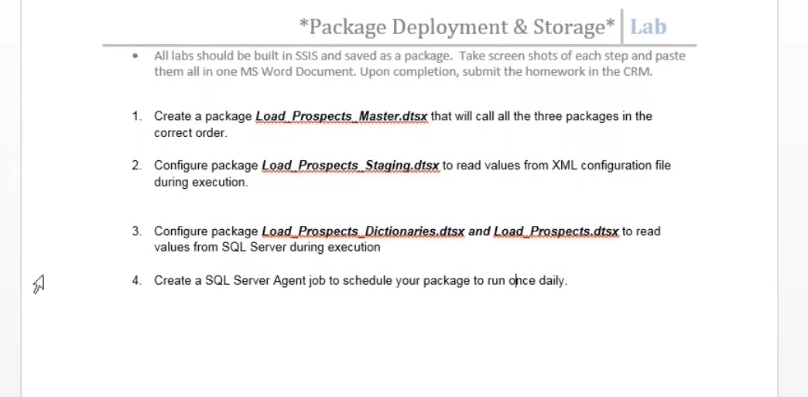

1….